2014-02-03 to 2014-02-05
I have spent the last two days to try and get phonegap to work. This in itself seem to be an appropriate project... I have messed around with Apache ant, Environmental variables, created two virtual machines to emulate two different distributions of Linux. Maybe it will work today. Trying once again to make it work in eclipse on windows.

I can finally compile and run “hello world”. The emulation is too slow to be useful. Trying to create an emulation of android in VMware

2014-02-08
Trying to invoke phonegap specific methods. Couldn't get the 'alert window' to show.
Found the problem. Remember phonegap and cordova are both used to describe the same thing for some reason.

The tutorial I used named the java script file “phonegap.js” as can be seen here:
<script type="text/javascript" charset="utf-8" src="phonegap.js"></script>

while the files from the web page call it “cordova.js”. The correct way would then, of course, be:
<script type="text/javascript" charset="utf-8" src="cordova.js"></script>

2014-02-09
Created the first look of the GUI and ran it on a virtual machine.
Flow: Start → Splash screen → Main Screen (Buttons and infobox)
Two buttons can be pressed. One shows the splash screen again and the other changes the infobox from “not connected” to “connected”.
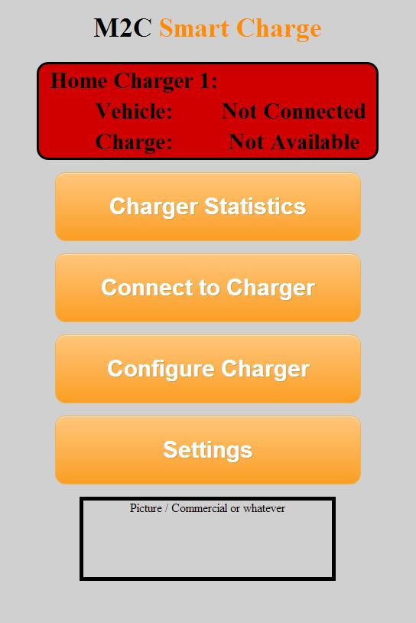
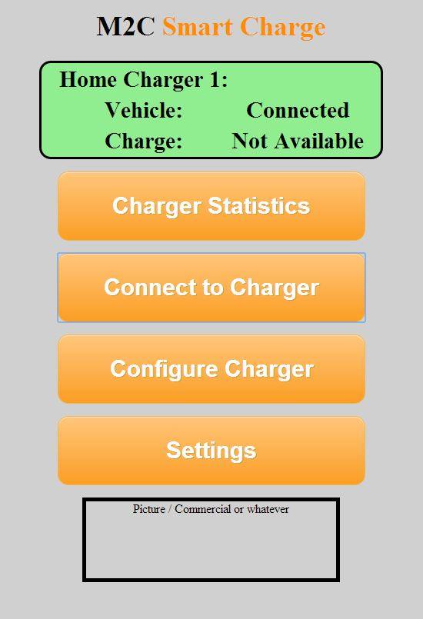

2014-02-10
Had another meeting with Hugh. I still don't have access to the lab room. So he is going to look in to that. We are also waiting for more information about the project. Right now I can't do much except play around with the GUI and get familiar with the tools I have available.

I am currently writing the timetable for the project. Since I need more information about how the program should look I can't create the timetable for the development. Hopefully Hugh has talked to them until next week (our next meeting) and I will write the missing parts then.

2014-02-17
Meeting with Hugh. Got access to the lab room and my own workstation.
I also got introduced to another student working on a phonegap application. There are supposed to be another group of two that I haven't met yet.

Hugh had a conference with the engineers. We will receive our own station next week. In two week we will meet again and Hugh will update me on how the program will work. Until then I will try to establish a connection between my app and a database.

The program will work towards a database to pull information. The details about executing commands are not worked out yet. Either I upload to the database and the deal with it or I interact directly with the station. Their station is, as of now, only a one-way communication. From the station to the database.

Wrote a big part of the background today. Mostly it contains text from the specification I received and some information from the M2C webpage.

2014-02-19
Made the application run on my Android Nexus phone. Made some gui changes concerning the size.

2014-02-21
I have been extending my first android app “helloGap” with the project functionality. It worked so good that I decided to actually use it as the project file and, therefor, rename it as M2C Application. This did not turn out to well. The project name was hard coded in to some configuration files which made the whole project stop working.

2014-02-28
Decided to redeploy the project from scratch (while reusing the working code) and write a thorough documentation of each step and what every part of the program do. This takes some time and will probably make this coming weeks deliverable delayed.

2014-03-03
I am now one year older and wiser. This will help me a lot I believe. Working on the redeployment in Eclipse and documentation. Was on a meeting with Hugh. The charger hasn't arrived yet and we decided that I should have the generic connection to a database done by the next meeting, Wednesday at 15 (12/3).

2014-03-05
I have finished the guide do make PhoneGap run on android. The moments after I had a meeting with another group working on PhoneGap where I received some vital information. To avoid having to reconfigure PhoneGap for each and every platform there is a cloud based service available on github where you upload your files and it will do all the configurations for you. But wait there is more. There are apparently a plug in available for chrome called Ripple. This makes running the application as fast as you can launch a web page. At least I know the basics of android now.

